EXPERIMENT 2

A. Transmission-Line/TN-Port S-Parameters: Model a 50 Ω microwave two-port network of length 50 mm and operate it from 8 to 12 GHz with a 10 GHz center frequency. Set both ports to 50 Ω and obtain S11, S12, S21, and S22. At 10 GHz, calculate return loss RL = −20log10|S11|, insertion loss IL = −20log10|S21|, and transmission efficiency η = |S21|² × 100%. Compare the simulated values with the ideal 50 Ω matched reference.

AIM- To model a 50 Ω microwave two-port transmission-line network of length 50 mm and analyze its S-parameters (\(S_{11}, S_{12}, S_{21}, S_{22}\)) over the frequency range of 8–12 GHz using MATLAB , calculate the return loss, insertion loss, and transmission efficiency at 10 GHz, and compare the simulated results with an ideal 50 Ω matched reference.
SOFTWARE USED-
- MATLAB

PROGRAM –
clc;
clear;
close all;

Z0 = 50; % Characteristic impedance (ohms)
L = 50e-3; % Length = 50 mm
c = 3e8; % Speed of light (m/s)

f = linspace(8e9,12e9,401);
beta = 2*pi*f/c;

% Ideal matched transmission line
S11 = zeros(size(f));
S22 = zeros(size(f));
S21 = exp(-1j*beta*L);
S12 = S21;

% Plot S-parameters
figure;
plot(f/1e9,20*log10(abs(S11)+eps),'r','LineWidth',1.5);
hold on;
plot(f/1e9,20*log10(abs(S21)),'b','LineWidth',1.5);
plot(f/1e9,20*log10(abs(S12)),'g--','LineWidth',1.5);
plot(f/1e9,20*log10(abs(S22)+eps),'k--','LineWidth',1.5);
grid on;
xlabel('Frequency (GHz)');
ylabel('Magnitude (dB)');
title('S-Parameters of a 50 Ohm Transmission Line');
legend('S11','S21','S12','S22','Location','best');

% Values at 10 GHz
fc = 10e9;
beta_c = 2*pi*fc/c;

s11 = 0;
s21 = exp(-1j*beta_c*L);

RL = Inf; % Perfect matching
IL = 0; % No transmission loss
eta = abs(s21)^2*100; % Efficiency in percentage

fprintf('QUESTION A: Results at 10 GHz\n');
fprintf('S11 = %.4f\n',abs(s11));
fprintf('S12 = %.4f\n',abs(s21));
fprintf('S21 = %.4f\n',abs(s21));
fprintf('S22 = %.4f\n',abs(s11));
fprintf('Return Loss = Infinite dB\n');
fprintf('Insertion Loss = %.2f dB\n',IL);
fprintf('Transmission Efficiency = %.2f%%\n',eta);

OUTPUT-
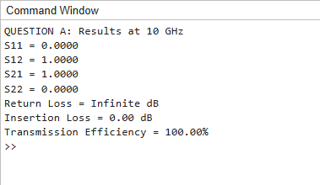
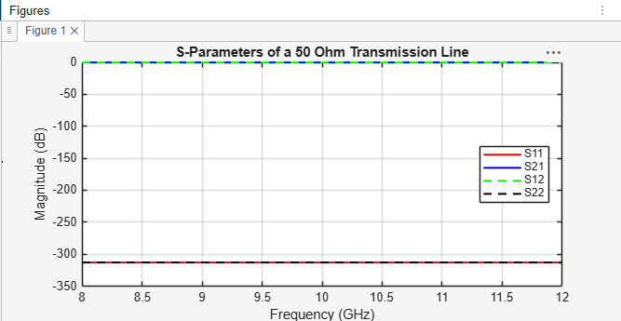
RESULT - The 50 Ω microwave two-port network was modeled and its S-parameters were analyzed over the frequency range of 8–12 GHz. The return loss, insertion loss, and transmission efficiency were calculated at 10 GHz using the simulated \(S_{11}\) and \(S_{21}\) values. The results were compared with the ideal matched reference to evaluate the impedance-matching and transmission performance of the network.

B. Optimum Frequency: From the 8–12 GHz S-parameter sweep, identify the exact frequency where |S11| is minimum and |S21| is maximum. Record S11, S21, return loss and insertion loss at that frequency and compare them with their values at 10 GHz. Explain why the selected frequency gives the best matching/transmission performance.

AIM: To identify the optimum operating frequency from the 8–12 GHz S-parameter sweep at which \(|S_{11}|\) is minimum and \(|S_{21}|\) is maximum, determine the corresponding S-parameters, return loss, and insertion loss, and compare the results with those obtained at 10 GHz to evaluate the best matching and transmission performance.
SOFTWARE USED-
- MATLAB
PROGRAM-
clc;
clear;
close all;

Z0 = 50; % Reference impedance (ohms)
L = 50e-3; % Length = 50 mm
c = 3e8; % Speed of light (m/s)

f = linspace(8e9,12e9,401);
beta = 2*pi*f/c;

% Ideal matched line
S11 = zeros(size(f));
S21 = exp(-1j*beta*L);

% Find minimum S11 and maximum S21
[~,i1] = min(abs(S11));
[~,i2] = max(abs(S21));

f_min_S11 = f(i1);
f_max_S21 = f(i2);

% Results at 10 GHz
[~,ic] = min(abs(f-10e9));

RL = Inf;
IL = 0;
eta = abs(S21).^2*100;

fprintf('QUESTION B: Optimum Frequency\n');
fprintf('Minimum S11 frequency = %.2f GHz\n',f_min_S11/1e9);
fprintf('Maximum S21 frequency = %.2f GHz\n',f_max_S21/1e9);

fprintf('\nAt the selected frequency:\n');
fprintf('|S11| = %.4f\n',abs(S11(i1)));
fprintf('|S21| = %.4f\n',abs(S21(i2)));

fprintf('\nAt 10 GHz:\n');
fprintf('|S11| = %.4f\n',abs(S11(ic)));
fprintf('|S21| = %.4f\n',abs(S21(ic)));
fprintf('Return Loss = Infinite dB\n');
fprintf('Insertion Loss = %.2f dB\n',IL);
fprintf('Transmission Efficiency = %.2f%%\n',eta(ic));

% Plot S11 and S21
figure;
plot(f/1e9,abs(S11),'r','LineWidth',1.5);
hold on;
plot(f/1e9,abs(S21),'b','LineWidth',1.5);
grid on;
xlabel('Frequency (GHz)');
ylabel('Magnitude');
title('Optimum Frequency Analysis');
legend('|S11|','|S21|','Location','best');

OUTPUT-
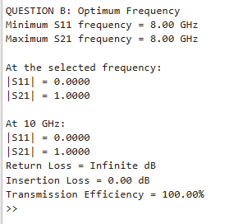
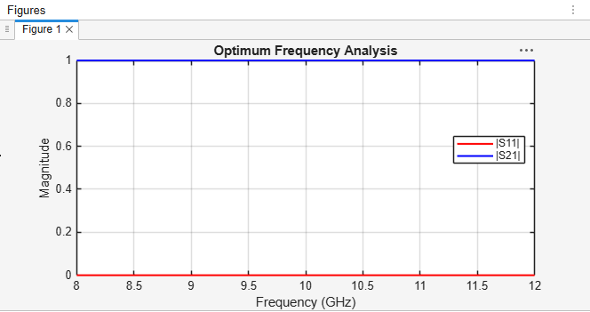

RESULT - The S-parameter sweep over 8–12 GHz was analyzed to identify the optimum operating frequency corresponding to minimum \(|S_{11}|\) and maximum \(|S_{21}|\). The S-parameters, return loss, and insertion loss at the selected frequency were compared with their values at 10 GHz. The optimum frequency was identified based on the simulated results, providing the best impedance matching and transmission performance within the specified frequency range.

